

**Name: Tayyba umar, Nadia Arshad, Rabia Nasir**

**Roll number :** **166, 153, 169**

**Assignment: Thermometric Titrations**

**Submitted to: DR. Naeem Khan**

**Govt graduate college of science wahdat road Lahore**

# **THERMOMETRIC TITRATION:**

**INTRODUCTION**

Each reaction involves an enthalpy change that leads to change in temperature. The amount of substance converted during the reaction determines the increase or decrease in the temperature. In Thermometric Titrations the reagent solution is added to sample at constant rate until attaining the end point.

The Thermometric Titrations make use of heat of reaction to obtain titration curves. In usual practice the Temperature of the solution is plotted against the volume of titrant

Following are the salient advantage of TT.

* Results can be obtained rapidly.
* Robust technique for routine work.
* Highly suitable for aggressive media.

**PRINCIPLE:**  The titrant is added at a known constant rate to the titrand until the completion of reaction is indicated by the change in the temperature. The end point of reaction is determined by inflection of a curve generated by the output of temperature measuring device. The end point is aptly indicated by q sharp break in curve. As the temperature sensor in TT has the 0.3 seconds response time and 10-3K resolution even minute change in enthalpy can be monitored rapidly.

# **INSTRUMENTATION OF TT:**

Experimental setup of TT consists of a reagent delivery system (motor driven Automated burette), an adiabatic reaction cell (such as Dewar flask with stirring device), An electronic temperature sensing system and

an amplifying and data processing System. In thermometric Titrations TT temperature control is most important and depends upon the results required. For precise Calorimetric results the titrant and sample must be close to the same temperature as far as possible and this is

achieved by a thermostat.

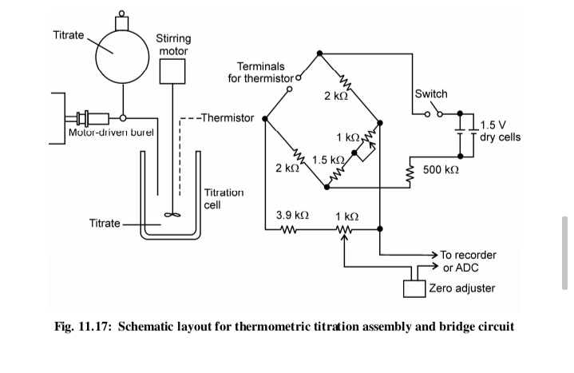

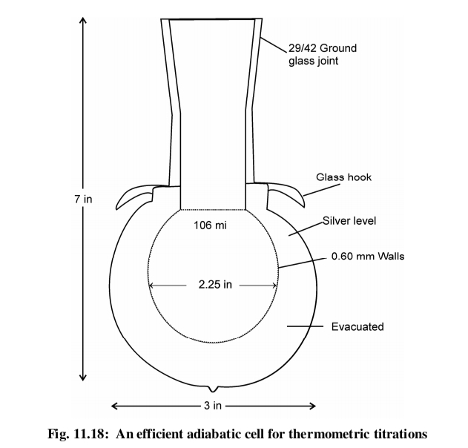

1. **DELIVERY PUMP:**A constant delivery pump permits the time axis of a strip chart Recorder to be used as the volume of titrant axis. Typically a syringe driven by a Synchronous motor which drives the screw is used and solution is delivered at a Constant rate ranging down to few µdm3 Per min. In DIE the syringe is rapidly emptied at the start of the experiment to deliver the Titrant instantaneously into the sample cell.
2. **ADIABATIC CELL:**

These have widely varying designs ranging from an insulated Beaker to a Dewar flask type cell .All the cells are designed to Minimize the heat transfer from the cell to the environment thus maximizing the Temperature change observed. When only titration end point is of interest, the Simple cell is sufficient. However, if quantities such as heat of reaction, Equilibrium constant or kinetic parameters are sought, it becomes essential to Use better cells which have thin walls to minimize the heat capacity and Maximize the speed of response to temperature change.

1. **CALIBRATION UNIT:**

In order to bring the cell quickly to thermal equilibrium, it is Essential to use calibration heater. It has two purposes, to determine the heat Capacity of the system and to control the temperature in the cell itself. The heat Evolved or absorbed is calculated from where A and B are constants whose values depend on the nature of the

It is the heart of thermometric titrator. The Principal temperature sensor is a thermistor which is temperature sensitive Semiconductor whose resistance obeys the equation;

**RT = AB/T**

where A and B are constants whose values depend on the nature of the thermistor. A thermistor has the advantage of being small size, fast response to temperature change and chemical resistance.

1. **AMPLIFICATION AND RECORDING** It is often advantageous to amplify the signal obtained from the thermistor. ADC amplifier is used to obtain good signals for temperature changes of the order of 10-4 °C or less. For still lower temperature changes of the order of 10-6 °C, and AC, Wheatstone bridge with a lock in amplifier is used.

**APPLICATIONS OF THERMOMETRIC TITRATIONS**

**1-Since heat of reaction is most general property of chemical process so**

**Thermometric titration have a wide range of applicability in quantitatively**

**Analysis.**

**2- Its use in determination of concentration of unknown substances ,reaction**

**Stoichiometry equilibrium and thermodynamic properties.**

**3-This technique is also used in acid-base titrations , redox titrations ,**

**Precipitation reactions and Complexometric titrations .**

**4-This technique is also used in standardizations of raw materials**

**5-This technique is robust and analysis can be automated.**

**LIMITATIONS OF TT**

**1 This technique is highly non-selective .**

**2-This technique is very time consuming which is its serious drawback.**

**3-The reaction of standard solution should be rapid but it doesn’t happen in this technique.**

**4-In general it can provide limited group of elements at a time .**

**5-This technique is not so reliable so that today’s chemists prefer other**

**Techniques over this.**